Jimmy Buffett

Date 2/23/22

To: Miami City Commission
From: Jimmy Buffett

Re: Preservation of Miami Marine Stadium

I am writing you to provide my wholehearted support for the preservation of Miami Marine Stadium

The need to save the Miami Marine Stadium for our future just won’t go away, kind of like a snowbird relative, visiting you this winter, who is still in your guest room. And to me, that is a good thing. That little cathedral of musical fun is still a big part of Miami history. It was the vision of Hilario Candela after he fled Cuba for Miami. And, it is named for Ralph Monroe, the renaissance sailor, who discovered the beauty of Biscayne Bay long before any of us.
The Barnacle, in the Grove, was his home, and is still one of my favorite places to visit for inspiration, and thoughts of what it must have been like to live there at the end of the last century. And even in its present state of disrepair; with graffiti saturated hallways and walls, its tenacious symbiotic desire, to remain entrenched to the shores of Biscayne Bay, is as strong as a conch’s love for its shell.
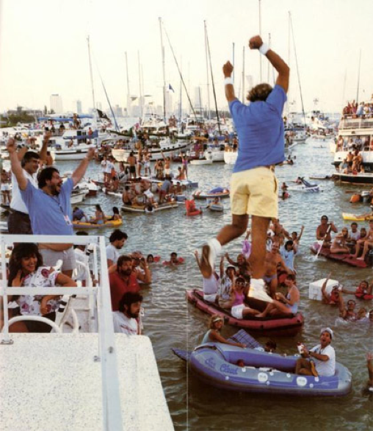

Coconut Grove was where I first landed in south Florida with the help of Jerry Jeff Walker back in 1972, when I left a not so successful career in Nashville. Those were the days in the Grove, playing at Bubba’s, and Monty Trainers. On many a bike rides out to Key Biscayne, I would peddle by the stadium, and dream of being on that stage one day. And I was not the first singer born in Mississippi, who had splashed around in the bay. Though Jerry Jeff got me to Coconut Grove, and later Key West, another singer, born in Mississippi, was the one who ignited my first dreams of getting to Miami. That was Elvis Presley, who sped around the course to a cheering crowd in the stands, in a hydroplane, to a climatic winning finish, in the 1967 movie “Clambake”.
Dreams do come true, and in 1985, I finally made it to that stage as a headline performer. Those were the Miami Vice days, and Don Johnson introduced us, the Witco Desperados from Trinidad opened the show, and the Coral Reefer Band finished the night with what I think was one of the most fun shows, for band and fans, that I have ever done. And as promised to my band and fans, I leapt from the stage into the Bay to finish the performance.
Now, when we all chose to make South Florida our home, hurricanes have to be an accepted part of life in these latitudes. And it was hurricane Andrew, that took its toll on the stadium. Since then, a great group of die-hard Marine Stadium worshipers (me included) have tried to keep the spirit of that venue alive, while we looked for the funds to restore the stadium, as a landmark venue. As a performer, I have been lucky enough to play, many historic venues, across the country from the Shell in Honolulu to the Hollywood Bowl, the Filmore in San Francisco, Red Rocks in Denver, Wrigley Field in Chicago and Fenway Park in Boston. The Miami Marine stadium, in its heyday, was then, and could be again on my list. I think the times are right for finding a few generous souls among the obvious many new citizens arriving daily in Dade County, who might be interested in helping the cause. Speaking as a transplant myself, they too obviously love all the things we love about the unique melting pot, that is the heart of Miami; and can hopefully join with us to restore and re-open the Ralph Monroe Marine Stadium. And when that day comes, l volunteer to play opening night for free. But I am so not sure about agreeing to leaping again from the stage into Biscayne Bay at the end of the show, like I did in 1985.
So, if any of you commission members might have attended one of our shows, back in “the day”, and carry your own wonderful memories of floating in the bay with the words to “Margaritaville” echoing over the water, please join us in trying to bring back the Marine Stadium for Miami and the world.

Fins Up.

Jimmy Buffett

